SIMATS ENGINEERING
ASSESSMENT TOOL 3

COURSE NAME: Database Management Systems
COURSE CODE: CSA05

COURSE OUTCOME COVERED

CO2: Apply the relational model, relational algebra, SQL query structures, and views to solve database querying and data manipulation problems. (BL3, BL6)

Activity Tool : Debugging & Optimisation Task (Low)
Assessment Tool Weightage: 10%

QUESTIONS
Q.No | Question | Bloom's Level
1 | Identify and correct errors in a given SQL CREATE TABLE statement with incorrect syntax and missing constraints. | BL2 – Understand
2 | Debug an SQL query that incorrectly uses aggregate functions without GROUP BY and fix the issue. Bloom’s Level: | BL2 – Understand
3 | Correct a faulty SELECT query where column names are misspelled or improperly referenced. | BL1 – Remember
4 | Fix errors in an SQL query using JOIN, where the join condition is missing or incorrect. | BL3 – Apply
5 | Identify and correct a subquery error where multiple values are returned instead of a single value. | BL2 – Understand
6 | Debug a VIEW creation statement that contains invalid column references or syntax errors. | BL1 – Remember
7 | Examine an SQL query with unnecessary conditions and optimize it by simplifying the WHERE clause. | BL3 – Apply
8 | Identify violations of integrity constraints in a given table and correct them. | BL2 – Understand
9 | Fix a relation that violates 1NF or 2NF by removing repeating groups or partial dependencies. | BL3 – Apply
10 | Identify redundant attributes in a relation and apply basic normalization (up to 3NF) to improve design. | BL3 – Apply

Code of Conduct:

I DARSHINIE KARANI.V.M(192520033) (Name / Reg No) certify that this submission is my original work and that I have adhered to the guidelines specified for this assessment.
I understand that any violation of academic integrity rules will result in disciplinary action.

Signature of the student:

RUBRICS FOR CALCULATION:

Criteria | Level 4 (Exemplary) | Level 3 (Proficient) | Level 2 (Developing) | Level 1 (Beginning)
Problem Identification | Accurately identifies all errors and root causes with clear understanding | Identifies most errors with minor gaps | Identifies some errors but misses key issues | Unable to identify errors correctly
Debugging | Applies systematic debugging techniques effectively to resolve issues | Uses appropriate debugging methods with minor errors | Limited debugging approach; requires guidance | Unable to debug or resolve issues
Optimization | Optimizes code by significantly improving time complexity using efficient algorithms | Improves time complexity with minor gaps in efficiency | Limited improvement in time complexity | No improvement; inefficient approach retained
Analysis | Demonstrates strong logical reasoning and clear justification of solutions | Shows reasonable analysis with some justification | Limited analysis; weak reasoning | No analytical reasoning demonstrated
Code Quality | Produces clean, well-structured code with proper comments and documentation | Code is mostly clear with minor documentation gaps | Code lacks structure and proper documentation | Poorly written code with no documentation

ANSWERS:

1.
DEBBUGED PROGRAM
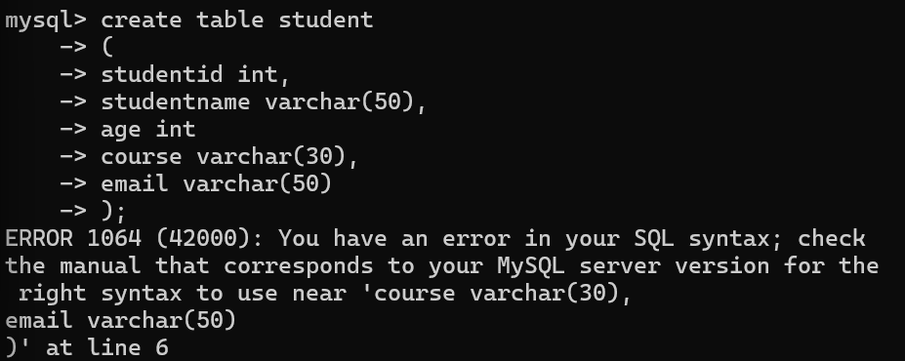

CORRECTED PROGRAM
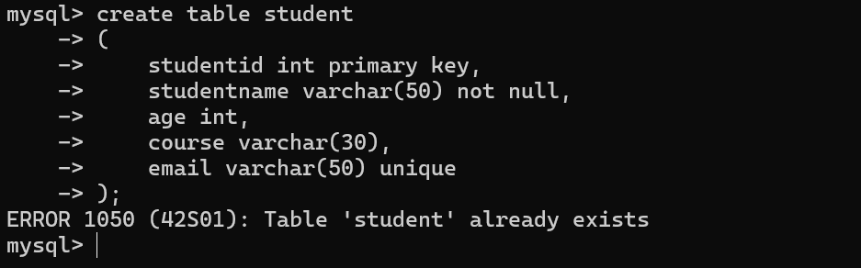
Verifying the program
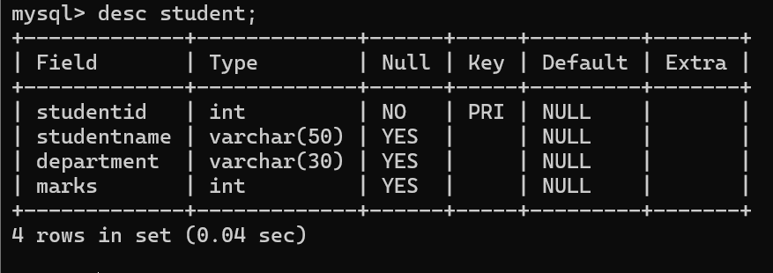

Explanation
- primary key ensures that each studentid is unique.
- not null ensures every student has a name.
- unique prevents duplicate email addresses.
- The missing comma after age int is added to correct the SQL syntax.
2.
CREATE TABLE STUDENT
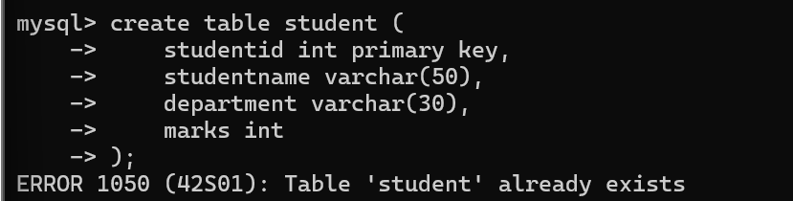
INSERT THE VALUES
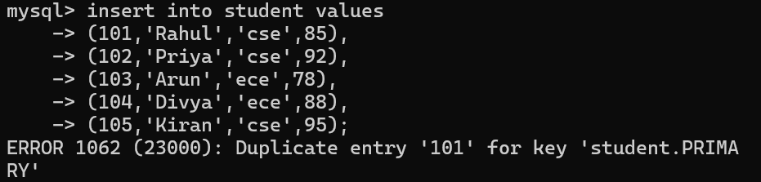
PROGRAM EXECUTION
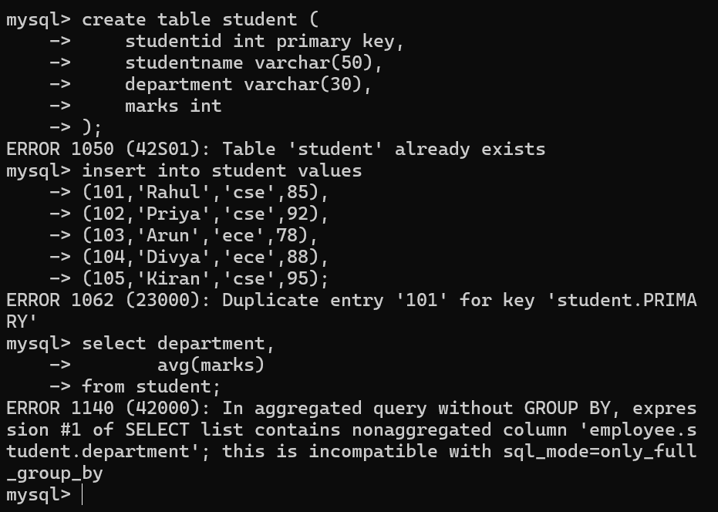
Error
- avg(marks) is an aggregate function.
- department is a non-aggregate column.
- The query is missing the group by clause.
CORRECTED PROGRAM
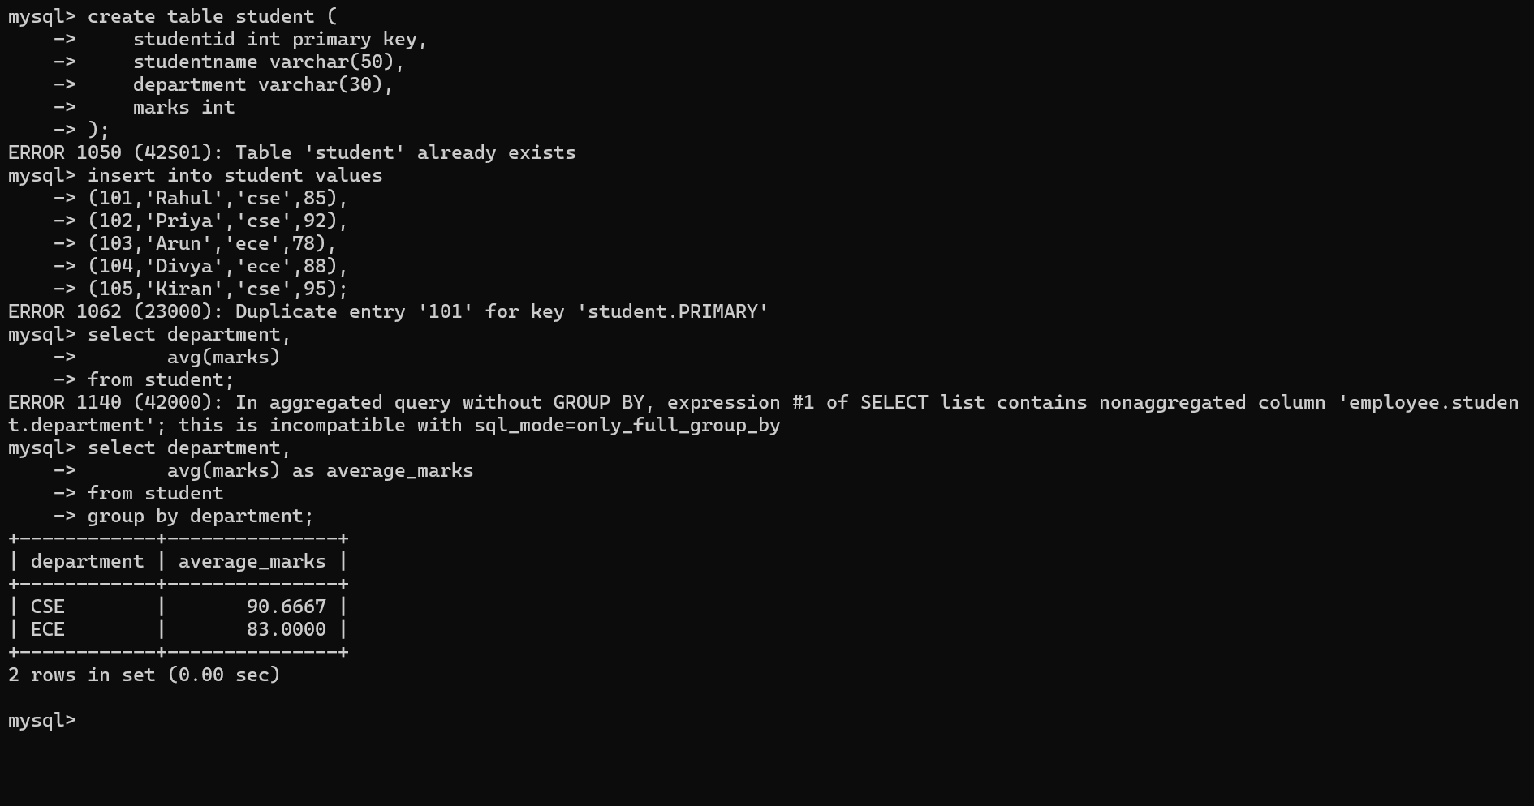
3.
CREATE TABLE FOR STUDENT
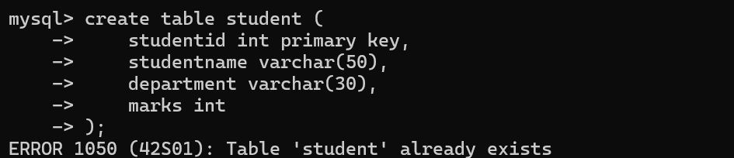
INSERT THE VALUES
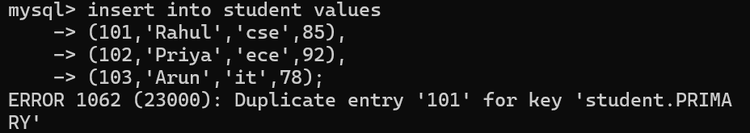
ERROR IN THE PROGRAM

Errors
- studntname is misspelled.
- departmnt is misspelled.
CORRECTED PROGRAM
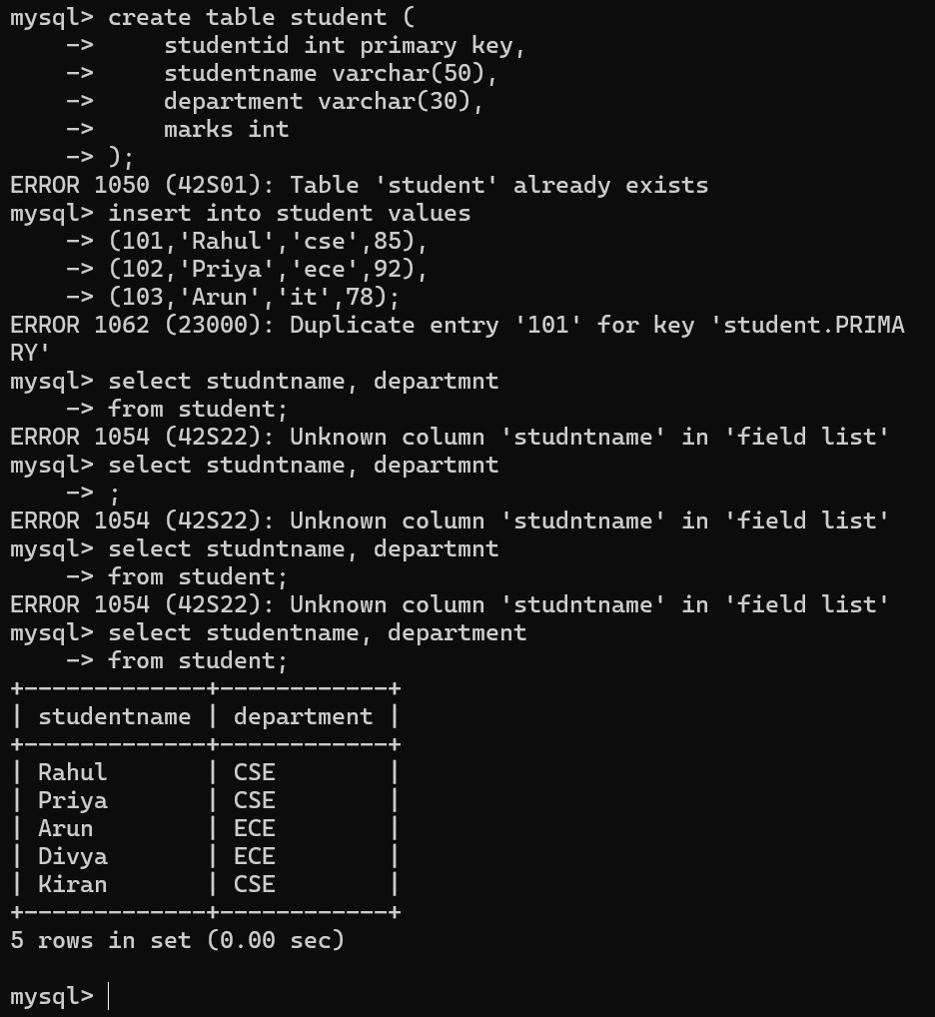
Explanation
- The column name studntname is corrected to studentname.
- The column name departmnt is corrected to department.
- After correcting the column names, the query executes successfully and retrieves the required data.
Conclusion
The error occurred because the column names were misspelled. Correcting them to the actual column names in the table allows the select query to execute successfully.
4.
Create Tables for student and course
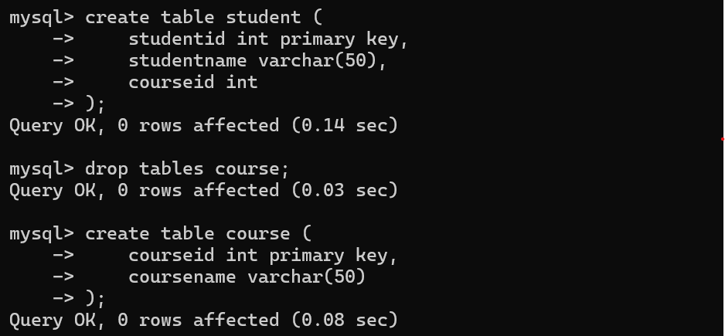

Insert Sample Data
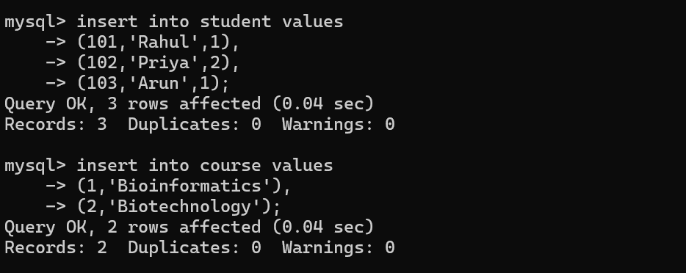
INCORRECT PROGRAM
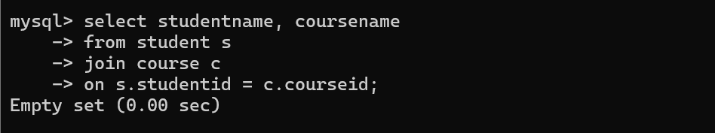

Error
The join condition is incorrect:
on s.studentid = c.courseid
studentid and courseid are unrelated columns, so this join will not return the correct results.
CORRECTED PROGRAM

Explanation
- join combines the student and course tables.
- courseid is the common column between the two tables.
- The corrected join condition:
on s.courseid = c.courseid;
correctly matches each student with their course.
Conclusion
The error was caused by an incorrect join condition. Replacing studentid with courseid in the on clause correctly joins the two tables and returns the expected results.
5.
CREATE TABLE STUDENT
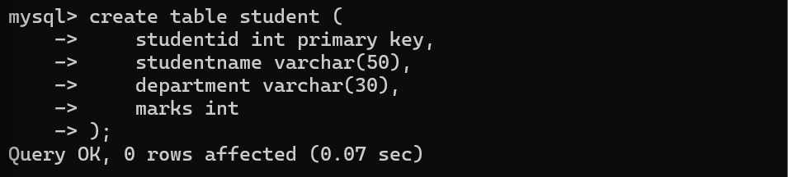

INSERT VALUES
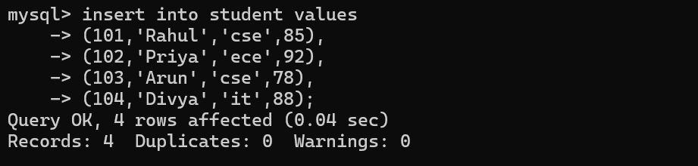

INCORRECT PROGRAM
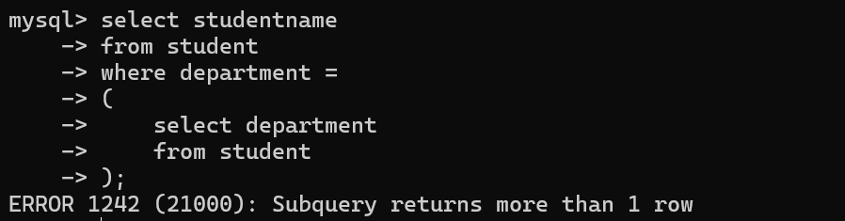
Error
The subquery returns multiple department values (cse, ece, it), but the = operator expects only one value.
CORRECTED PROGRAM
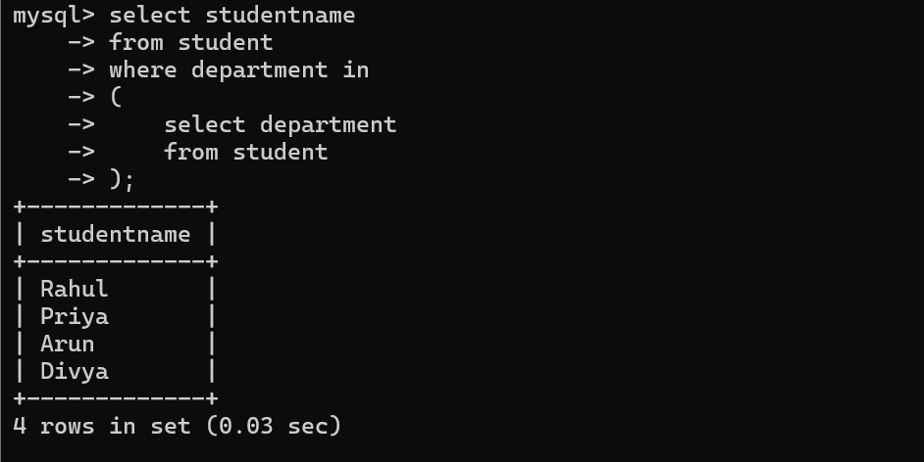

Explanation
- The subquery returns multiple department values.
- The = operator can compare only a single value.
- Replacing = with in allows comparison with multiple values returned by the subquery.
- The corrected query executes successfully.
Conclusion
The error occurred because the subquery returned multiple rows while the = operator expected a single value. Replacing = with in correctly handles multiple values and fixes the query.
6.
Create Table
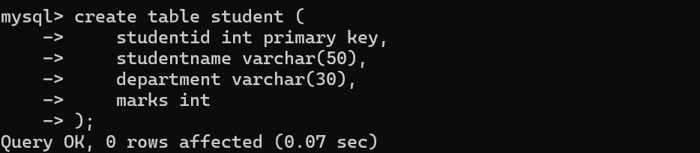
Insert Values
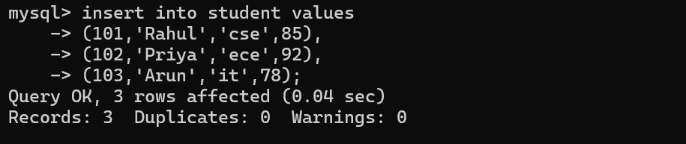

Debugged program
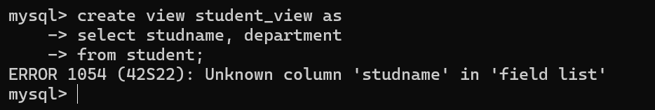
Error
- The column studname does not exist in the student table.
- The correct column name is studentname.

CORRECTED PROGRAM
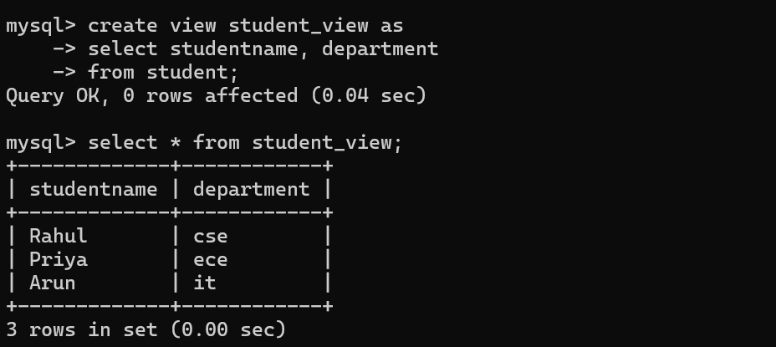
Explanation
The error occurred because the column name studname was invalid. Replacing it with the correct column name studentname fixes the create view statement. The view now displays only the studentname and department columns from the student table.
Conclusion
The view creation failed because of an invalid column reference. Correcting the column name allows the view to be created successfully and simplifies data retrieval from the student table.
7.
CREATE TABLE EMPLOYEE
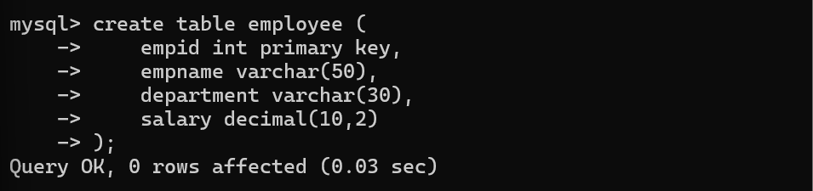
INSERT VALUES
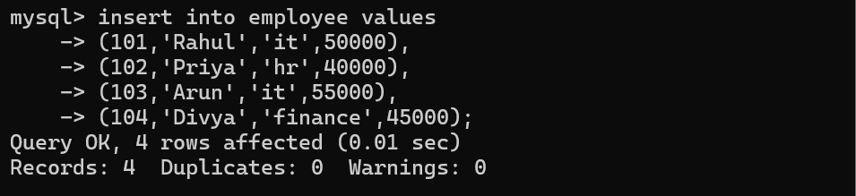

INCORRECT PROGRAM
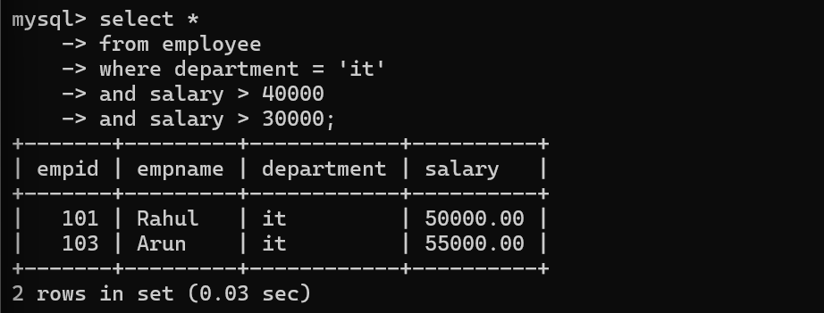
Problem
The condition:
salary > 30000
is unnecessary because:
salary > 40000
already ensures that the salary is greater than 30000.
OPTIMISED SQL QUERY
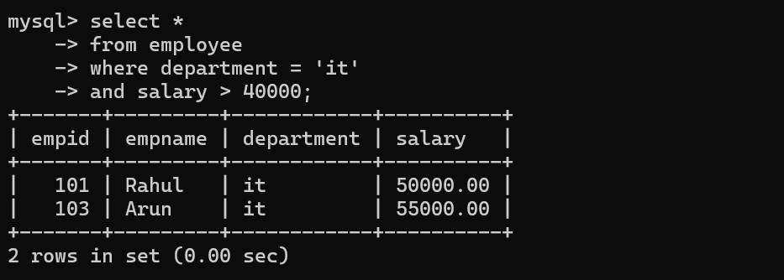

Explanation
The original query contained a redundant condition:
salary > 30000
Since salary > 40000 already satisfies this condition, it was removed. The optimized query is simpler, easier to read, and executes more efficiently while producing the same result.
Conclusion
The query was optimized by removing the unnecessary condition from the where clause. This improves readability and query performance without changing the output.
8.
Create table employee
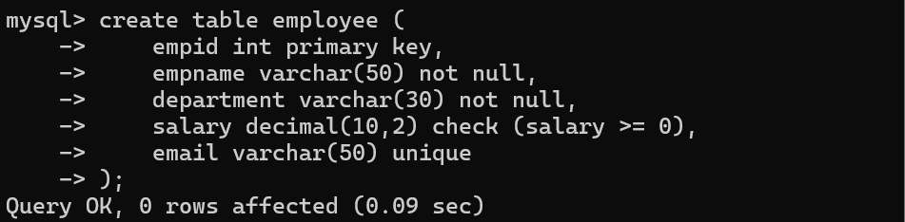

Incorrect Insert Statements (Violates Integrity Constraints)
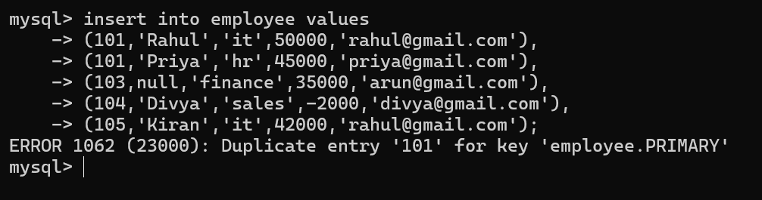

Violations

Violation | Reason
Duplicate empid (101) | Violates primary key constraint.
empname is null | Violates not null constraint.
Salary = -2000 | Violates check (salary >= 0) constraint.
Duplicate email  rahul@gmail.com | Violates unique constraint.

Correct Insert Statements
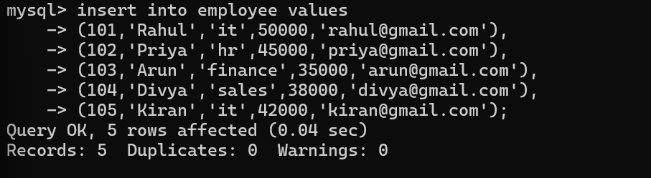
Display the Table
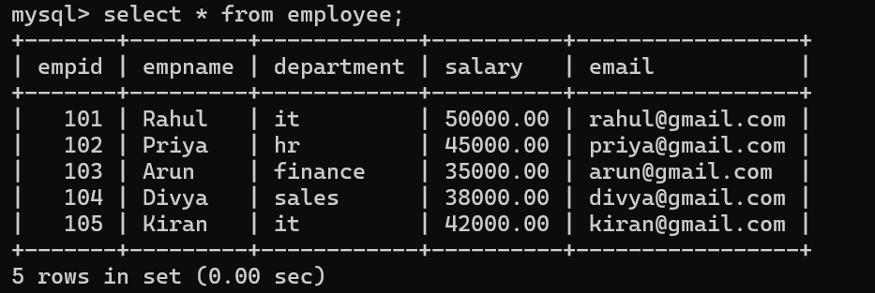
Explanation
The original records violated several integrity constraints. A duplicate employee ID violated the primary key constraint, a null employee name violated the not null constraint, a negative salary violated the check constraint, and a duplicate email violated the unique constraint. After correcting these values, all records satisfy the integrity constraints and can be inserted successfully.
Conclusion
Integrity constraints help maintain the accuracy and consistency of the database. By enforcing primary key, not null, check, and unique constraints, duplicate, invalid, and inconsistent data are prevented, ensuring reliable database operations.
9.
Relation Violating 1NF
Suppose the following table stores multiple phone numbers in a single column.

studentid | studentname | phoneno
101 | Rahul | 9876543210, 9876501234
102 | Priya | 9123456789
103 | Arun | 9988776655, 9876123456

Problem
The phoneno column contains multiple values in a single cell. This violates First Normal Form (1NF) because every attribute must contain only one atomic value.

Convert to 1NF
Split the repeating phone numbers into separate rows.

studentid | studentname | phoneno
101 | Rahul | 9876543210
101 | Rahul | 9876501234
102 | Priya | 9123456789
103 | Arun | 9988776655
103 | Arun | 9876123456
Now every column contains only one value, so the relation satisfies 1NF.
SQL Table
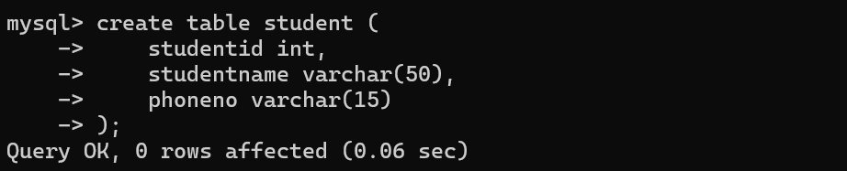
Insert Correct Values
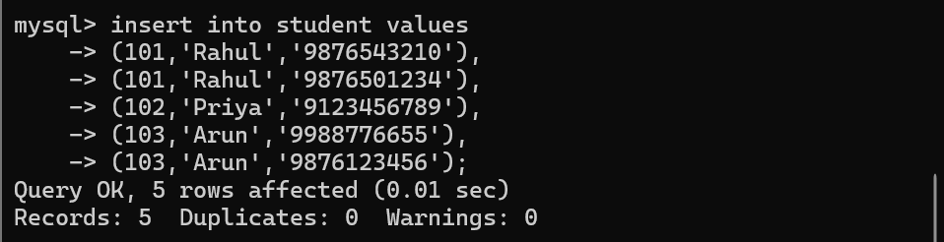
Display the Table
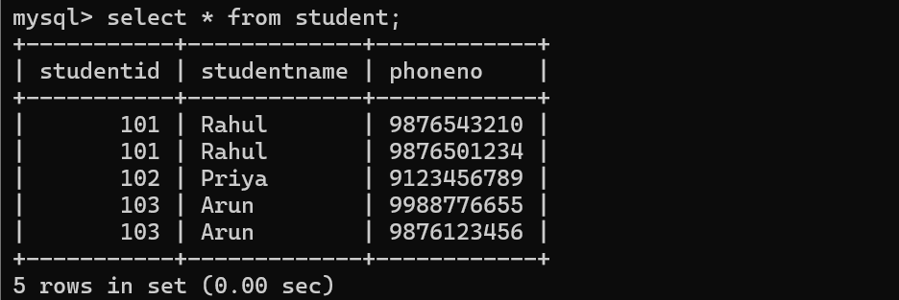

Explanation
The original relation violated First Normal Form (1NF) because the phoneno column contained multiple values in a single field. By storing each phone number in a separate row, every attribute now contains a single atomic value. This removes repeating groups and ensures the relation satisfies 1NF.

Conclusion
The relation was normalized by removing repeating groups from the phoneno column. After decomposition, the table satisfies First Normal Form (1NF), reducing redundancy and improving data consistency.
10.
Unnormalized Relation
Consider the following relation:

studentid | studentname | courseid | coursename | faculty | facultyphone
101 | Rahul | c101 | DBMS | Kumar | 9876543210
102 | Priya | c101 | DBMS | Kumar | 9876543210
103 | Arun | c102 | Java | Meena | 9123456789
104 | Divya | c102 | Java | Meena | 9123456789

Identify Redundant Attributes
The following attributes are repeated unnecessarily:
- coursename
- faculty
- facultyphone
For every student enrolled in the same course, these values are repeated, causing data redundancy.

Problems
- Update Anomaly: If the faculty phone number changes, it must be updated in multiple rows.
- Insertion Anomaly: A new course cannot be added unless a student enrolls.
- Deletion Anomaly: If the last student leaves a course, the course details are lost.

Normalize to 2NF
Separate the student and course information.
studentid | studentname | courseid
101 | Rahul | c101
102 | Priya | c101
103 | Arun | c102
104 | Divya | c102

course

courseid | coursename | faculty | facultyphone
c101 | DBMS | Kumar | 9876543210
c102 | Java | Meena | 9123456789

Normalize to 3NF
Assume each faculty has a unique phone number. Store faculty details separately.
studentid | studentname | courseid
101 | Rahul | c101
102 | Priya | c101
103 | Arun | c102
104 | Divya | c102

course

courseid | coursename | facultyid
c101 | DBMS | f01
c102 | Java | f02

faculty

facultyid | faculty | facultyphone
f01 | Kumar | 9876543210
f02 | Meena | 9123456789

Final 3NF Schema
student(studentid, studentname, courseid)
course(courseid, coursename, facultyid)
faculty(facultyid, faculty, facultyphone)

Explanation
The original relation contained redundant attributes such as coursename, faculty, and facultyphone, which were repeated for every student enrolled in the same course. This caused update, insertion, and deletion anomalies. By separating the data into student, course, and faculty tables, redundancy is eliminated and all transitive dependencies are removed. The resulting schema satisfies Third Normal Form (3NF).

Conclusion
The relation was normalized up to 3NF by separating student, course, and faculty information into different tables. This eliminates redundant attributes, improves data integrity, reduces storage space, and makes the database easier to maintain.

